
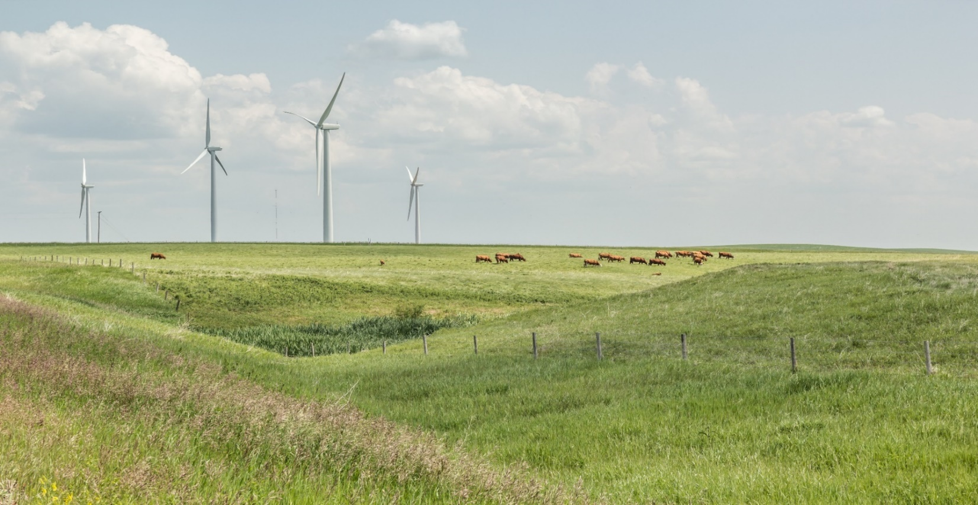
Date:Click or tap to enter a date. Applicant’s company name:Click or tap here to enter text.
Checklist application for new power plants equal to or greater than one MW and less than 10 MW

Identification and attestation
Name, position and contact information of applicant contact: Click or tap here to enter text.

I, acting in my position as set out above, have personally reviewed all of the information included and referenced in this application and affirm that, to the best of my knowledge, all information is correctly stated and reflects the existing records of the company. I further affirm that the information is complete and consistent with the Commission’s requirements and is not false or misleading in all material respects.
Yes ☐ No ☐

Project details
The total capability of the power plant in megawatts (MW): Click or tap here to enter text.
The power plant is:
Wind ☐ Solar ☐ Thermal ☐ Other (specify) ☐ Click or tap here to enter text.

For wind and solar power plants, submit a signed renewable energy referral report from Alberta Environment and Protected Areas (AEPA) Fish and Wildlife Stewardship. Please submit along with your application.
The location of the project is: Click or tap here to enter text.
The legal description of the project is: Click or tap here to enter text.

Provide a Keyhole Markup Language (.kml/.kmz) file that contains the geographic data of each of the major components, including substation locations and project boundary of the proposed power plant. Please submit along with your application.

The description of the project including the make and model of the generator units, wind turbines, solar photovoltaic panels or batteries and the key parameters (e.g., hub height and rotor-swept area for wind power plants, the tracking system for solar power plants).

The company is a qualified owner to hold a power plant approval pursuant to Section 23 of Hydro and Electric Energy Act.
Yes ☐ No ☐

If a municipality or subsidiary of a municipality will hold an interest in a generating unit, it will comply with Section 95 of the Electric Utilities Act?
Yes ☐ No ☐ N/A ☐

Construction start date:Click or tap to enter a date.

Construction completion date:Click or tap to enter a date.

Proposed in-service date:Click or tap to enter a date.
Participant involvement requirements
No person is directly and adversely affected, there are no outstanding objections.
Yes ☐ No ☐
There is no First Nation’s reserve, Metis Settlement or Crown lands within the consultation radii?
Yes ☐ No ☐

Technical considerations
The project will comply with Rule 012: Noise Control.
Yes ☐ No ☐

For a wind power plant, a shadow flicker assessment has been conducted and there are no outstanding concerns.
Yes ☐ No ☐ N/A ☐

For a solar power plant, a solar glare assessment has been conducted and there are no outstanding concerns.
Yes ☐ No ☐ N/A ☐

The project has or will have a corporate or site-specific emergency response plan for the construction and operation of the power plant.
Yes ☐ No ☐

The local responders and authorities have been contacted or notified regarding the project emergency response plan and there are no outstanding concerns.
Yes ☐ No ☐
Connection
If a connection order is being applied for concurrently, describe how the project will be connected: Click or tap here to enter text.

For a distribution-connected power plant
Identify the distribution facility owner: Click or tap here to enter text.
The distribution facility owner is willing to connect the proposed project.
Yes ☐ No ☐ N/A ☐

For a transmission-connected power plant
The Alberta Electric System Operator has not raised any concerns with the proposed connection.
Yes ☐ No ☐ N/A ☐

End-of-life management
The project will be decommissioned and reclaimed at the project end of life in accordance with applicable legislative requirements and the operator will ensure sufficient funds are available at the project end of life to cover the cost of decommissioning and reclamation.
Yes ☐ No ☐
For wind and solar power plant applications greater than 5 MW and less than 10 MW, the applicant will provide reclamation security to the Government of Alberta.
Yes ☐ No ☐

Environmental requirements
There will be no adverse effect on the environment as a result of the project.
Yes ☐ No ☐

Hazardous material or contaminant will be managed in accordance with applicable standards and guidelines.
Yes ☐ No ☐ N/A ☐

Potential changes to air quality from the project are expected to be minimal on a local and regional scale, and the project is expected to meet the Alberta Ambient Air Quality Objectives.
Yes ☐ No ☐ N/A ☐

Approvals and assessments from other agencies
The applicant will fulfill the requirements of all other agencies with jurisdiction over the project, including municipalities.
Yes ☐ No ☐

Visual impact
The power plant is not located within a buffer zone or a visual impact assessment zone described in Schedule 2 and Schedule 3 of the Electric Energy Land Use and Visual Assessment Regulation.
Yes ☐ No ☐

The Commission shall not accept any applications for the construction or operation of a wind power plant in a buffer zone as defined in Schedule 2 of the Electric Energy Land Use and Visual Assessment Regulation.

If the project is located within a buffer zone or a visual impact assessment zone described in Schedule 2 and Schedule 3 of the Electric Energy Land Use and Visual Assessment Regulation, provide a visual impact assessment in accordance with Section 8 of the Electric Energy Land Use and Visual Assessment Regulation.

Other considerations
If you answered no to any of the questions above, please explain: Click or tap here to enter text.
The project raises issues not addressed by the preceding questions.
Yes ☐ No ☐

If yes, please explain: Click or tap here to enter text.

